Emerging Leaders of the Americas Program (ELAP) 2025-2026
Application Form for Student

In each section, you will see screenshots from the ELAP website for your reference. Please make sure to select and type in each answer section highlighted in yellow.
IMPORTANT: The complete application must be in Word format.

- CANDIDATE INFORMATION

- Prefix/Salutation (Mandatory): ______
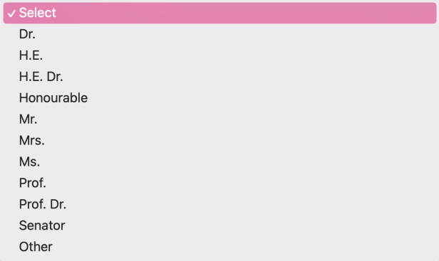
- First Name as shown on passport (Mandatory): ______
- Last Name as shown on passport (Mandatory): ______
- Gender (Mandatory): ______
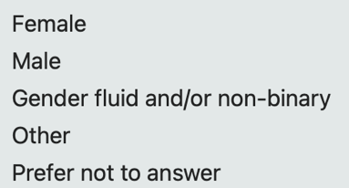
- Date of birth (dd/mm/yyyy) (Mandatory): ______
- Email (Mandatory): ______
- Country of Citizenship (Mandatory): ______
- Degree Sought at Home Institution (Mandatory): ______
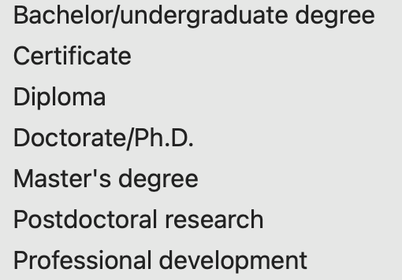
- Field of Study (Mandatory): ______

- Discipline (Mandatory): ______

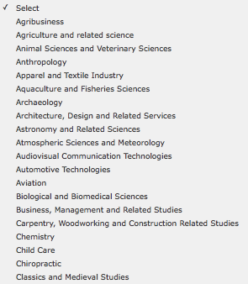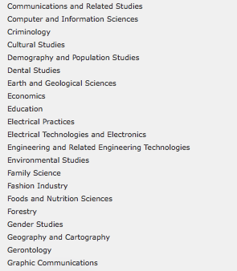
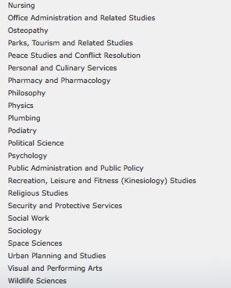
- Expected Completion Date of Degree (mm/yyyy) (Mandatory): ______
To be eligible, you must be:
- a student enrolled full-time at post-secondary institution in an eligible country/territory
- paying tuition fees to that institution at the time of application and for the full duration of your exchange

- SCHOLARSHIP INFORMATION
*Please note: Research students may NOT take classes, as they are expected to work full-time (35 hours per week) on their research projects. This option is best suited for Graduate students who are working on their thesis or dissertation research, and whose home supervisor is already collaborating with a Lakehead professor.

Undergraduate students may apply for research stay if there is a genuine research collaboration already existing.

Students are encouraged to discuss with their home supervisor(s) before contacting a potential supervisor at Lakehead. Students are responsible for proposing their own research project and finding their own supervisor at Lakehead. For assistance with research applications, please contact Jill Sherman at intl.research@lakeheadu.ca. If you would like to do a combination of classes and research (e.g. independent study), please apply as a STUDY student.

Program (Select One By Marking “X”):

- College/Undergraduate (Study only, Research in certain cases only) – 4 months or 1 academic term: ______
- Graduate (Study or Research) – 4 months or 1 academic term: ______
- Graduate (Research only) – 5 or 6 months: ______

The type of exchange activity the candidate will undertake at the Canadian institution (Select One By Marking “X”):
- Research : ______
- Study Not applicable: : ______

Length of Stay: Expected Start Term of Scholarship at Lakehead University (Mark “X”):
- Academic Stay:
Fall Semester (September 1, 2025 – December 31, 2025) and Winter Semester (January 1, 2026 – April 30, 2026)
  - Fall 2025: ______
  - Winter 2026: ______
- Research Stay: We do not guarantee on-campus housing for students attending Lakehead University because we have such a high demand for our housing. *We highly recommend you select your research start date to align with our academic start dates in either Fall or Winter*

  - Expected Start Date of Scholarship (dd/mm/yyyy) (Mandatory): ______
  - Expected End Date of Scholarship (dd/mm/yyyy) (Mandatory): ______

- CANDIDATE’S HOME POSTSECONDARY INSTITUTION
- Institution Name in English (Mandatory): ______ (No short forms and no abbreviations will be accepted.)
- Address (Mandatory): ______
- City/Town (Mandatory): ______
- Province/State/Region (Mandatory): ______ (No short forms or abbreviations)
- Postal Code/ZIP (Mandatory): ______
- Country (Mandatory): ______

- CONTACT PERSON RESPONSIBLE FOR THE EMERGING LEADERS IN THE AMERICAS PROGRAM (ELAP) AT THE CANDIDATE’S HOME INSTITUTION
- Prefix/Salutation (Mandatory): ______
- First Name (Mandatory): ______
- Last Name (Mandatory): ______
- Job Title (Mandatory): ______
- Department/Office (Mandatory): ______
- Phone (Mandatory: Country Code + Phone #): ______
- Email (Mandatory): ______

- CANADIAN ACADEMIC SUPERVISOR INFORMATION
FOR RESEARCH APPLICANTS ONLY:
*Please note: Research students may NOT take classes, as they are expected to work full-time (35 hours per week) on their research projects. This option is best suited for Graduate students who are working on their thesis or dissertation research, and whose home supervisor is already collaborating with a Lakehead professor.

Undergraduate students may apply for research stay if there is a genuine research collaboration already existing.

Students are encouraged to discuss with their home supervisor(s) before contacting a potential supervisor at Lakehead. Students are responsible for proposing their own research project and finding their own supervisor at Lakehead. For assistance with research applications, please contact Jill Sherman at intl.research@lakeheadu.ca. If you would like to do a combination of classes and research (e.g. independent study), please apply as a STUDY student.

- Prefix/Salutation (Mandatory): ______
- First Name (Mandatory): ______
- Last Name (Mandatory): ______
- Job Title (Mandatory): ______
- Department/Office (Mandatory): ______
- Phone: ______
- Email (Mandatory): ______
- Lakehead Campus location for your supervisor (Mark “X” to Select)”
  - Thunder Bay ___
  - Orillia ___

- FOR ACADEMIC STUDY/UNDERGRADUATE STUDENTS ONLY:
- Provide a list of 3-4 undergraduate level Lakehead courses to be undertaken
Please reference the Academic Calendar for the course codes and names.
NOTE - Students are not eligible to take courses in the following departments: Nursing, Social Work, Education, Law and Medicine (Mandatory): ___________________________________________________________________________________

- Lakehead Campus location for your study semester (Mark “X” to Select)”
  - Thunder Bay ___
  - Orillia ___

Please see the next page for an explanation of the
ELAP Supporting Documents - For Student

ELAP Supporting Documents - For Student

All of the following documents must be in English. Each document must be smaller than 5 MB in order for the coordinator to upload your application and supporting document successfully.

- Completed ELAP 2025/2026 Application Form in Word format only

- Proof of citizenship:
  - a copy of the candidate's passport (highly recommended for submission) or national identity card with a photo and valid dates
  - documents not accepted as proof of citizenship are: driver’s license, permanent residence card, work permit, student card, health card, birth certificate or baptismal certificate
  - proof of citizenship selected must be from the same country/territory as the citizenship selected in the online application form

Sample | 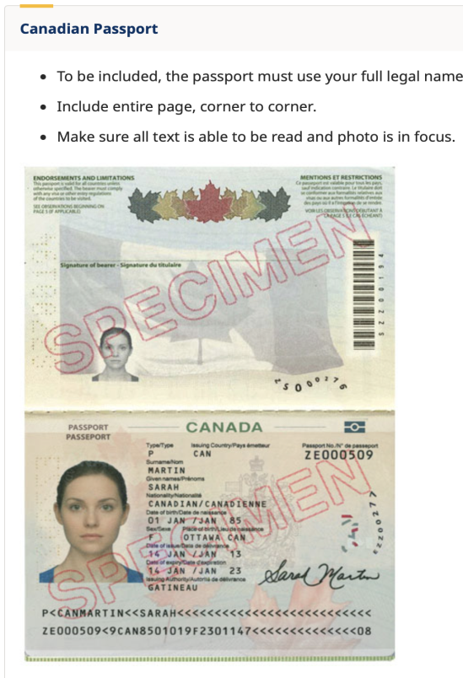

- Letter of proof of full-time enrolment from the home institution
  - on official letterhead
  - dated within the last six months
  - confirming that the candidate is currently enrolled in a full-time program
  - The type of program and the level of study of the candidate at the home institution;
  - The full-time enrolment status at the home institution; and
  - The anticipated completion date of the degree at the home institution.
  - Note: copies of transcripts, a student card or a letter of admission are not acceptable
  - Note: The letter of enrolment MUST say the words “full-time” in the document
- Letter of intent from the candidate (maximum one page)
  - explains the nature of studies or research to be undertaken
  - provides rationale for study in Canada and for the choice of institution, program and supervisor and how the proposed program of study or research will relate to their future career

- Letter of support from the home institution (maximum one page)
  - on official letterhead
  - dated within the last six months
  - from the candidate's instructor, professor or international director
  - explains the nature of study or research to be undertaken in Canada and how the candidate and the home institution will benefit from this scholarship program
Key factors for a successful support letter:
- Personalized letters will increase the candidate’s chances to receive the scholarships (Move away from a template)
- Explain how would the ELAP scholarship impact the candidate's future study and goals?
- Explain what the benefits are to your institution by sending a student to Canada?
- Letter of invitation from the Canadian supervisor (maximum one page)
  - only required for research stay - undergraduate/graduate candidates
  - on official letterhead
  - dated within the last six months
  - signed by the Canadian supervisor
  - describes the nature and scope of the research collaboration with the student’s home institution
  - confirms their willingness to support and mentor the candidate during the exchange period
  - explains how the Canadian institution, supervisor and peers will benefit from the exchange

- Academic Study (Undergraduate) Applications ONLY
  - A list of 3-4 Lakehead University courses the applicant is interested in taking: Students can reference our academic calendar from our current 2024/2025 academic year when looking for courses to take. The courses for the 2025/2026 academic year will not be available until approximately June 2025. However, most courses will still be available, and it will give them an idea of what is available to them for study. HERE is the link to our academic calendar. The student will need to choose the program they are interested in (example: Business), and then it will list the courses available. Please note that these courses can be changed. NOTE - Students are not eligible to take courses in the following departments: Nursing, Social Work, Education, Law and Medicine
  - Lakehead Campus choice for the student’s chosen study semester: Thunder Bay or Orillia

- Privacy Notice Statement: a copy of the Privacy Notice Statement for non-Canadian participants (linked here) signed by the candidate and dated within the last six months (this document is attached to this email).

